EXPT NO:6A | DATA VISUALIZATION USING POWER BI

AIM:
To import, transform, analyze, and visualize data using Power BI Desktop and create interactive dashboards and reports for decision-making.

ALGORITHM:
- Start the Power BI application.
- Import the Research Student dataset into Power BI using Get Data.
- Load the dataset into Power BI.
- Check the columns and clean the data using Power Query if required.
- Remove duplicate records and handle missing values.
- Create required calculated fields/measures.
- Create a bar chart to compare student-related categories.
- Create a pie chart to display category-wise distribution.
- Create a line chart to represent trends between numerical attributes.
- Create a card visual to display important summary values.
- Add suitable titles, labels, filters, and slicers.
- Arrange the visuals into a Power BI dashboard.
- Analyze the visualizations and identify important patterns.
- Save the Power BI report.
- Stop.

OUTPUT:
Importing
Data into Power BI:
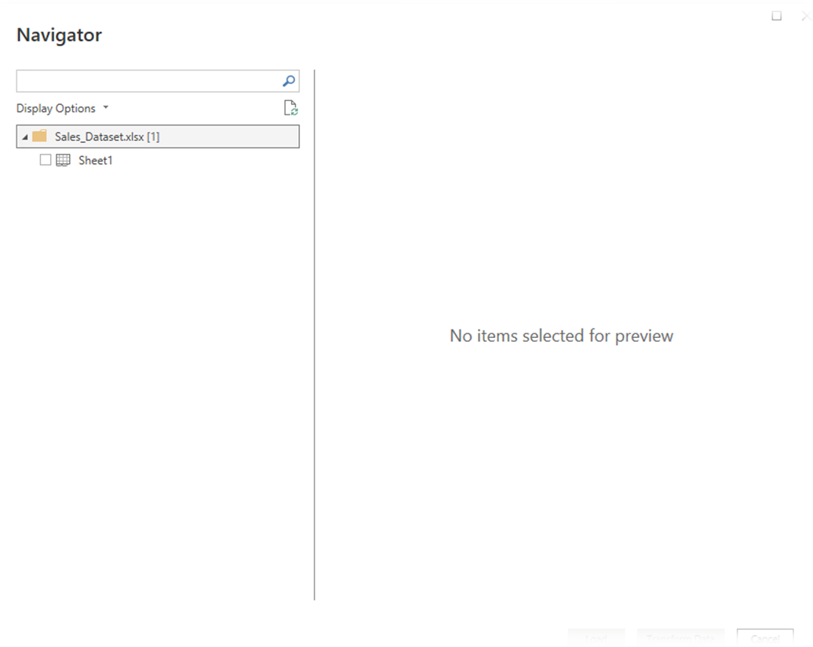

Imported dataset displayed in Data View:
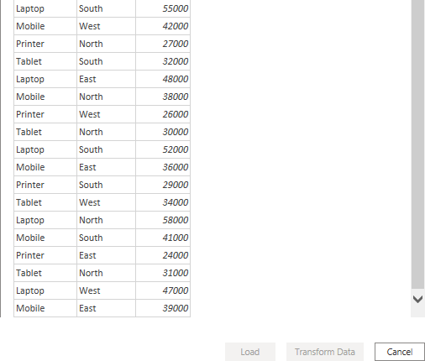

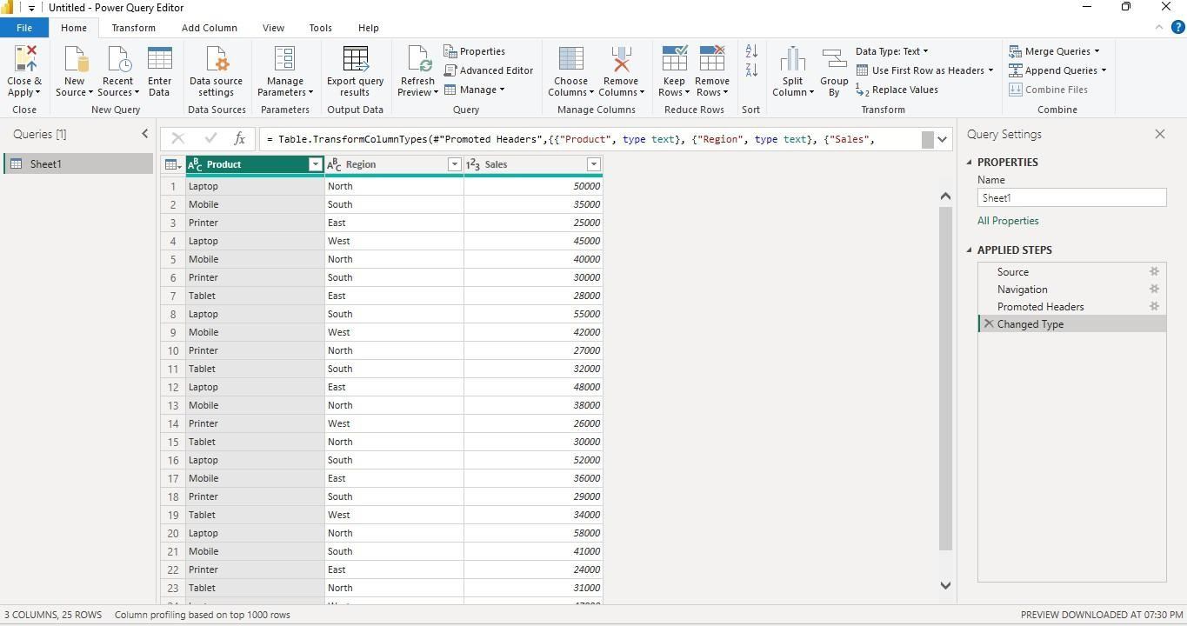
Cleaned dataset loaded successfully:
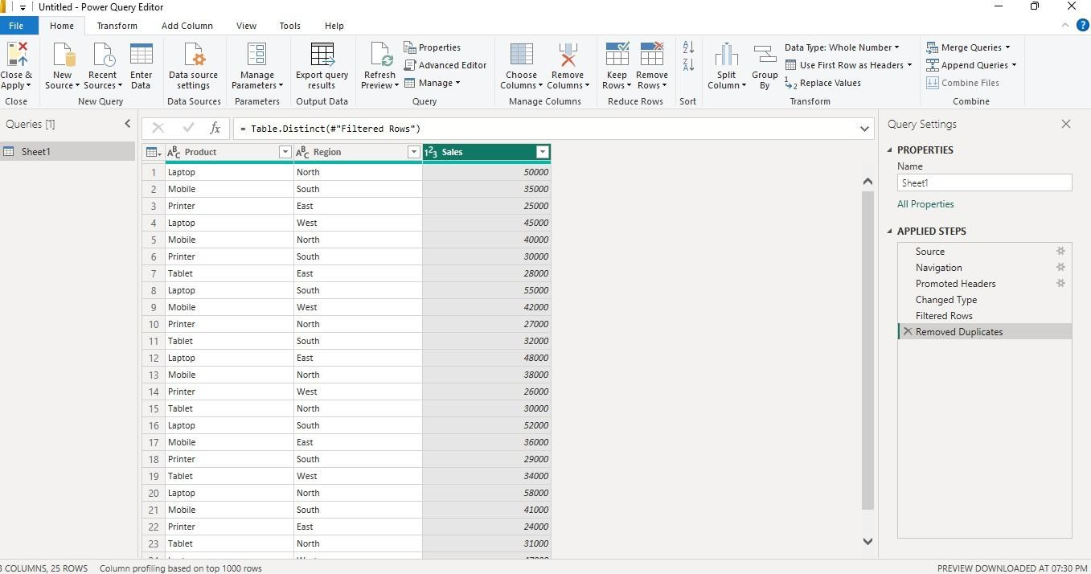
Creating a Bar Chart Product-wise Sales

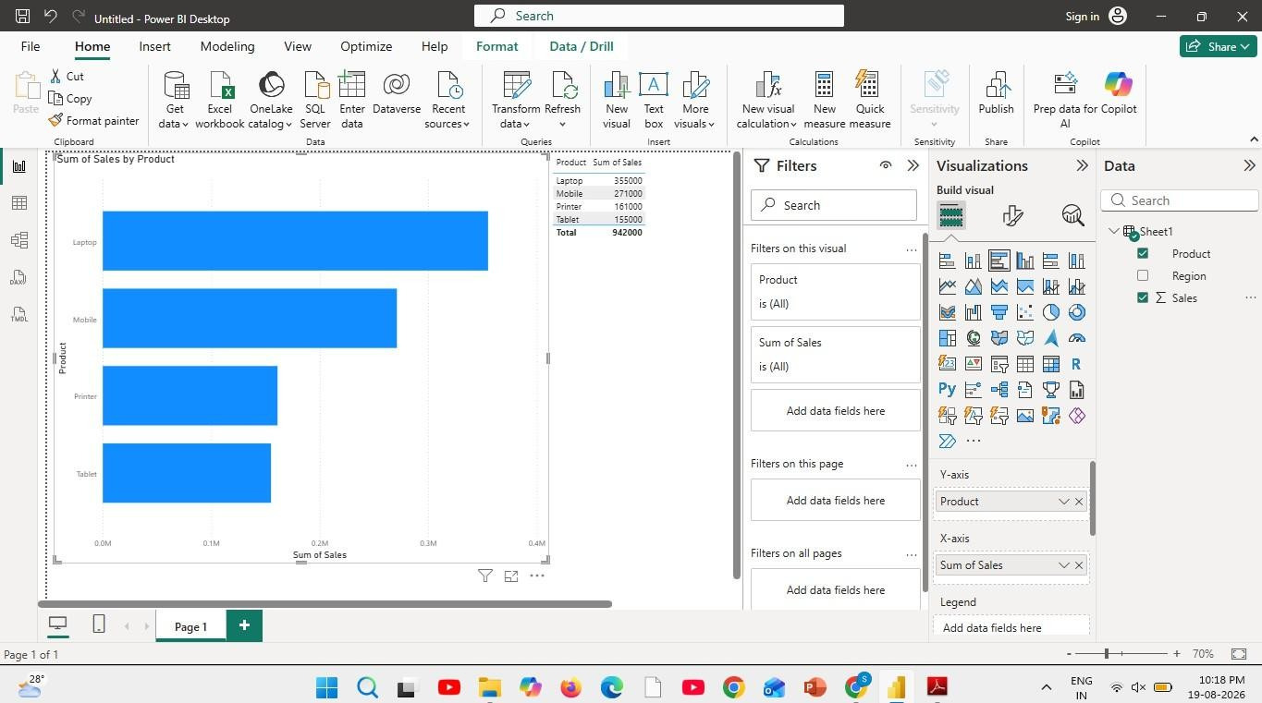
Sales comparison across products.
Creating a Pie Chart Sales Contribution
Percentage contribution of each product
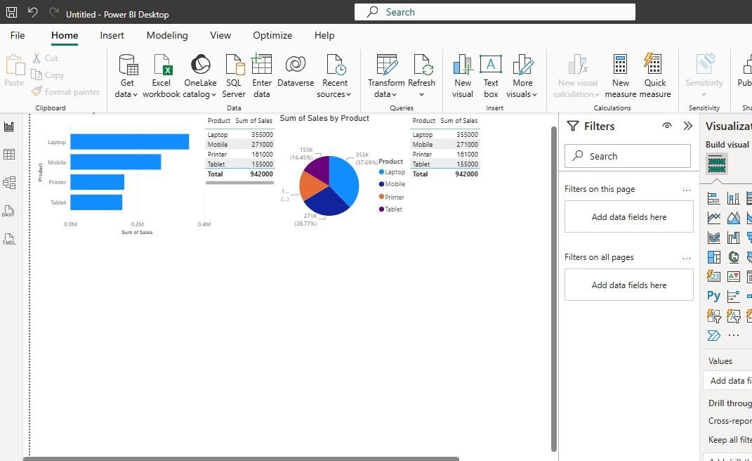

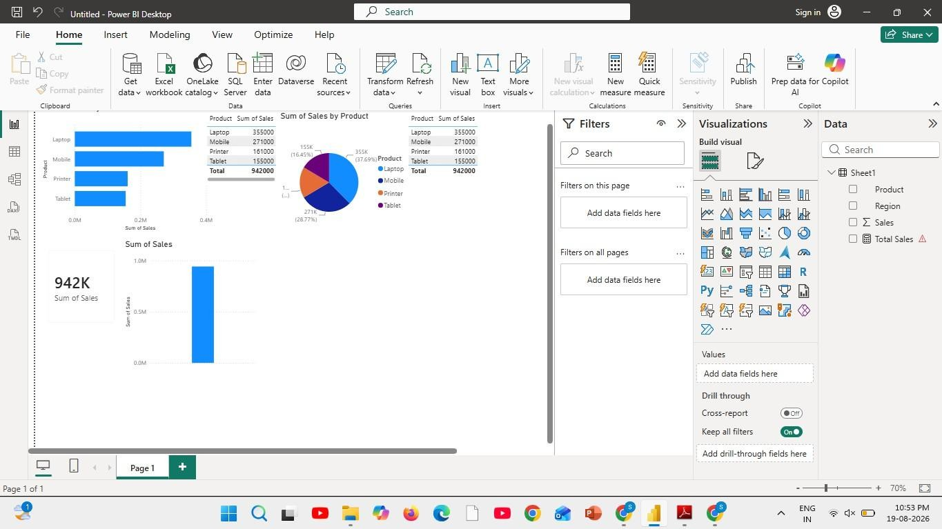
Creating a KPI Card
Creating Slicers:
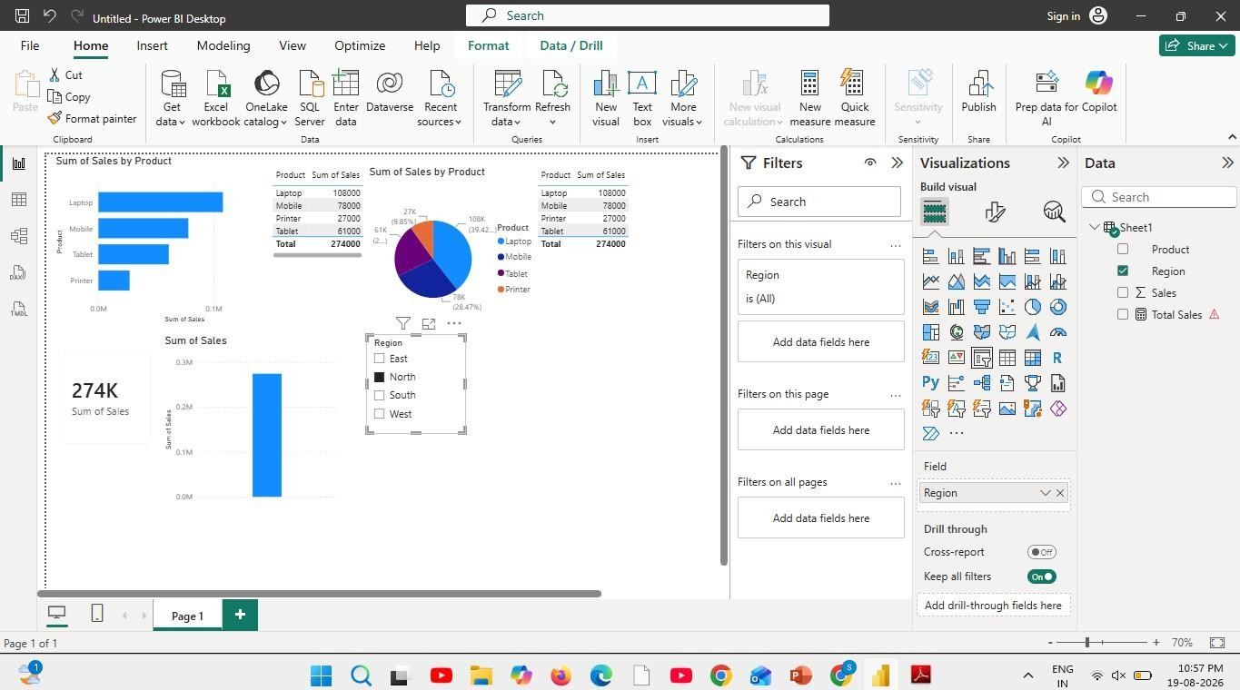
Creating DAX Calculations:

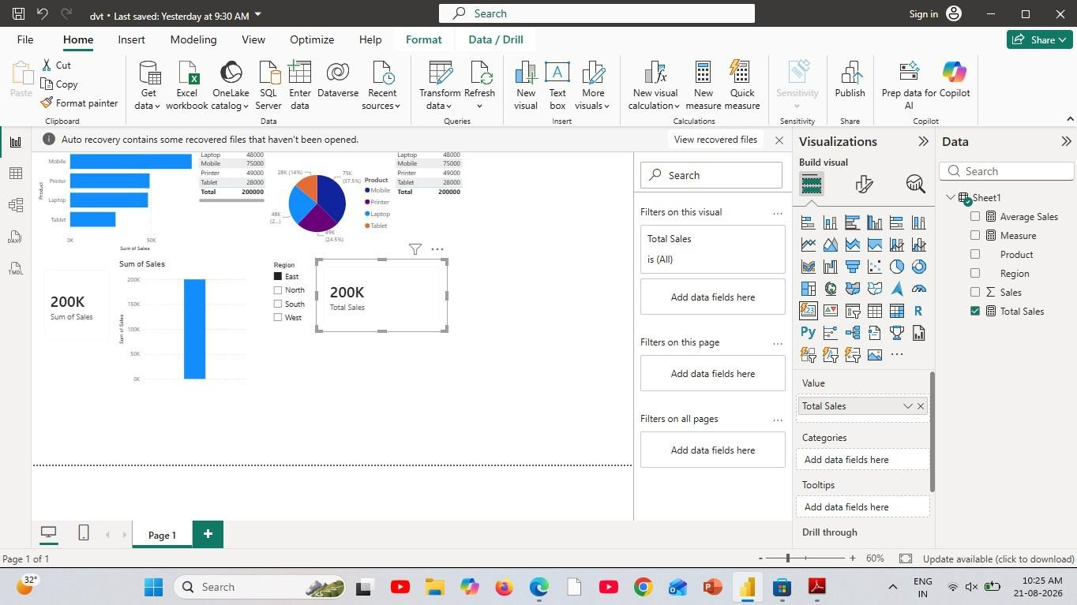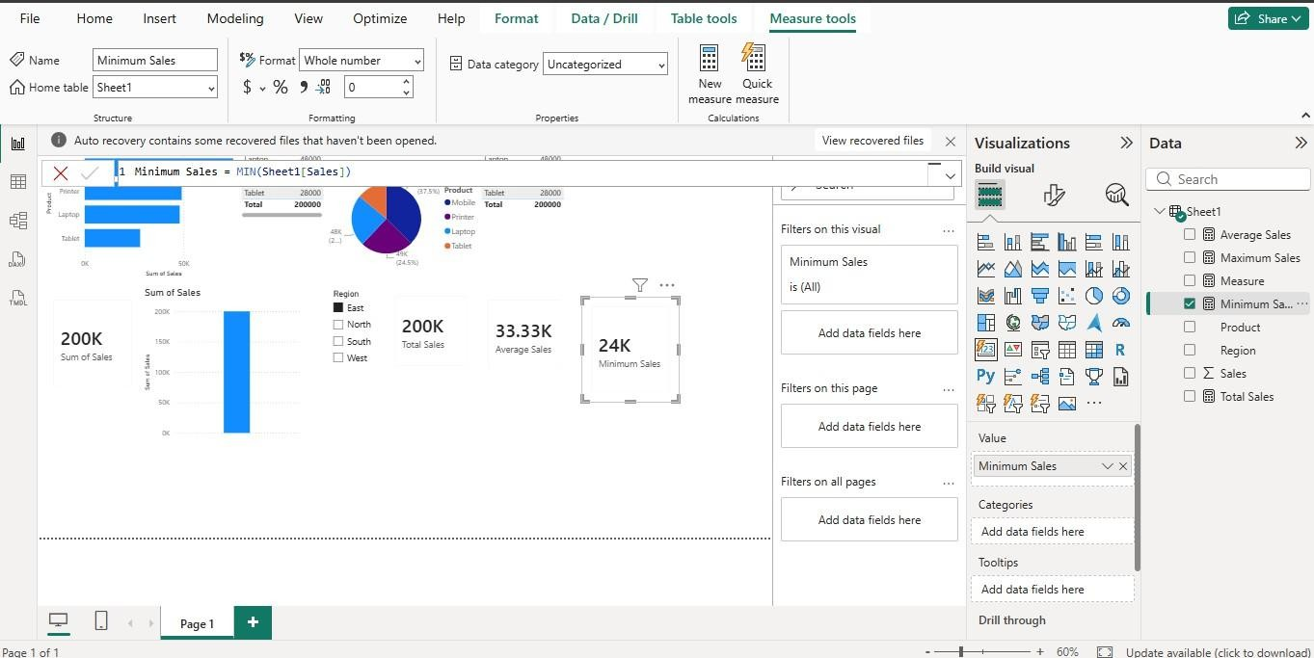

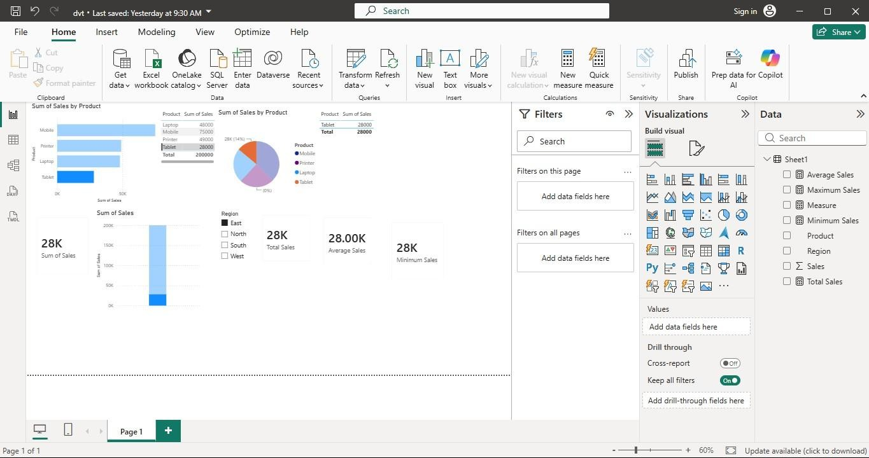
Creating Dashboard:
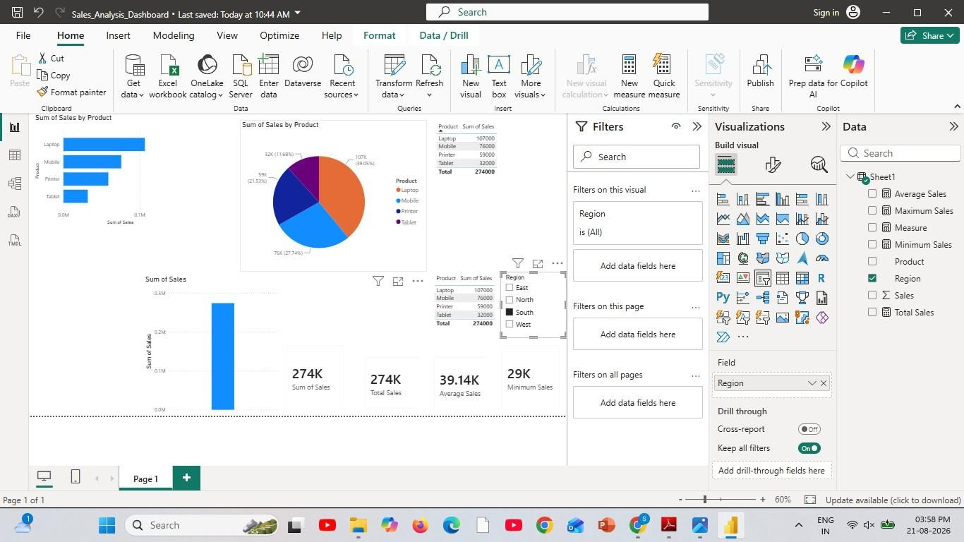

Result:

EXPT NO:6B | DATA VISUALIZATION USING POWER BI (ADVANCED STATISTICS ANALYTICS)

Aim:
To load the Player dataset into Power BI, transform and clean the data using Power Query, create calculated fields and measures, and develop interactive visualizations to analyze players based on player information, height, weight, birthday, and related attributes.

Algorithm:
ALGORITHM 1: IMPORTING DATA INTO POWER BI
Step 1
Open Power BI Desktop.
Step 2
Select:
Home → Get Data
Step 3
Choose Text/CSV.
Step 4
Browse and select the Player CSV dataset.
Step 5
Click Load to import the dataset.
Step 6
Verify the imported columns and records in the Data View.

ALGORITHM 2: DATA TRANSFORMATION USING POWER QUERY
Step 1
Select Transform Data.
Step 2
Open the Power Query Editor.
Step 3
Check the column names and assign appropriate data types to numerical and categorical columns.
Step 4
Remove duplicate records based on the player information.

Step 5
Handle missing or null values in columns such as player_name, birthday, height, and weight.
Step 6
Clean and standardize player information such as player_name.
Step 7
Remove unnecessary columns if required.
Step 8
Click Close & Apply to load the transformed dataset into Power BI.

ALGORITHM 3: ADVANCED DATA TRANSFORMATIONS
Step 1
Select the Height column and ensure that it has an appropriate numeric data type.
Step 2
Select the Weight column and convert it into a numeric data type.
Step 3
Select the Birthday column and convert it into an appropriate date/time data type.
Step 4
Check columns related to Year, Month, or Day from Birthday and convert them into appropriate date or numeric formats.
Step 5
Handle missing values in numerical columns by replacing them appropriately or filtering invalid records.
Step 6
Create additional categories or groups where required, such as height and weight ranges for comparing different player groups.
Step 7
Click Close & Apply to load the cleaned dataset into the Power BI model.

ALGORITHM 4: CREATING CALCULATED COLUMN AND MEASURES
Step 1
Navigate to Report View or Table View.
Step 2
Right-click the dataset table and select New Column.
Step 3
Create a calculated column to determine BMI from height and weight:

BMI =
DIVIDE([weight], ([height] * [height] / 10000), 0)
Step 4
Create a measure to calculate total players:
Total Players =
COUNTROWS(Player)
Step 5
Create a measure to calculate average height:
Average Height =
AVERAGE([height])
Step 6
Create a measure to calculate average weight:
Average Weight =
AVERAGE([weight])
Step 7
Create additional measures such as maximum height or average weight for further analysis.

ALGORITHM 5: DASHBOARD VISUALIZATION & REPORTING
Step 1
Select a Line Chart and map the available Year field to the X-axis and Height or Weight to the Y-axis to analyze trends.
Step 2
Select a Bar/Column Chart and map Player Name or Height/Weight Group to the X-axis and Height or Weight to the Y-axis.
Step 3
Select a Donut/Pie Chart to display the distribution of players based on Height Group or Weight Group.
Step 4
Select a Bar Chart to identify the Top Players by Weight.
Step 5
Create another chart to identify players by Height.
Step 6
Add Card Visuals to display important summary values such as:
- Total Players
- Average Height
- Average Weight

Step 7
Add Slicer visuals for Year, Height Group, and Weight Group to enable interactive filtering.
Step 8
Arrange all the visuals into a meaningful and interactive Player Analytics Dashboard.
Step 9
Add suitable titles, labels, legends, and formatting to improve the readability of the dashboard.
Step 10
Analyze the dashboard to identify patterns such as player height distribution, weight distribution, and birth-year trends.
Step 11
Save the Power BI report as a .pbix file.

Output:
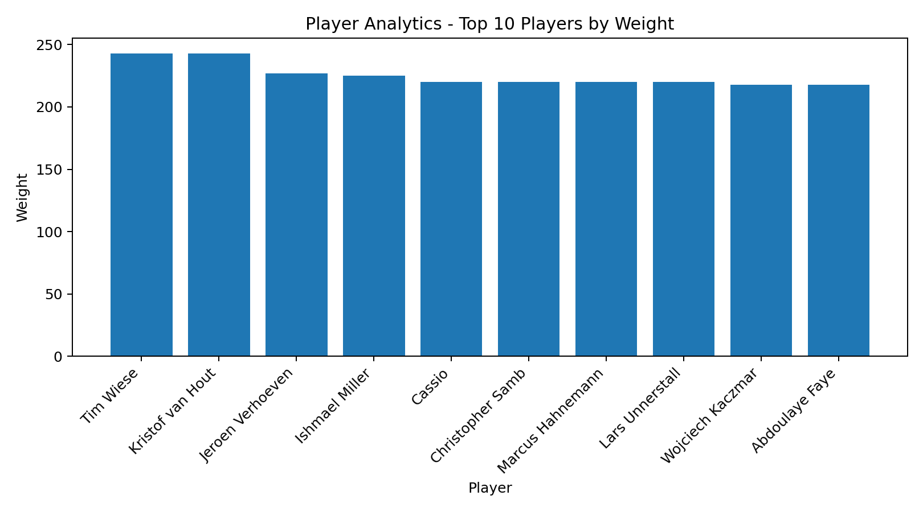
Output: Top 10 Players by Weight
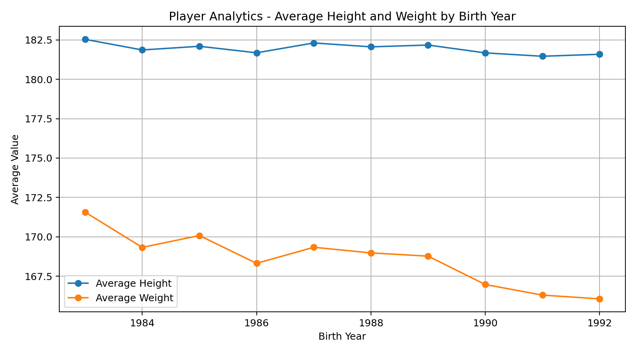
Output: Average Height and Weight by Birth Year
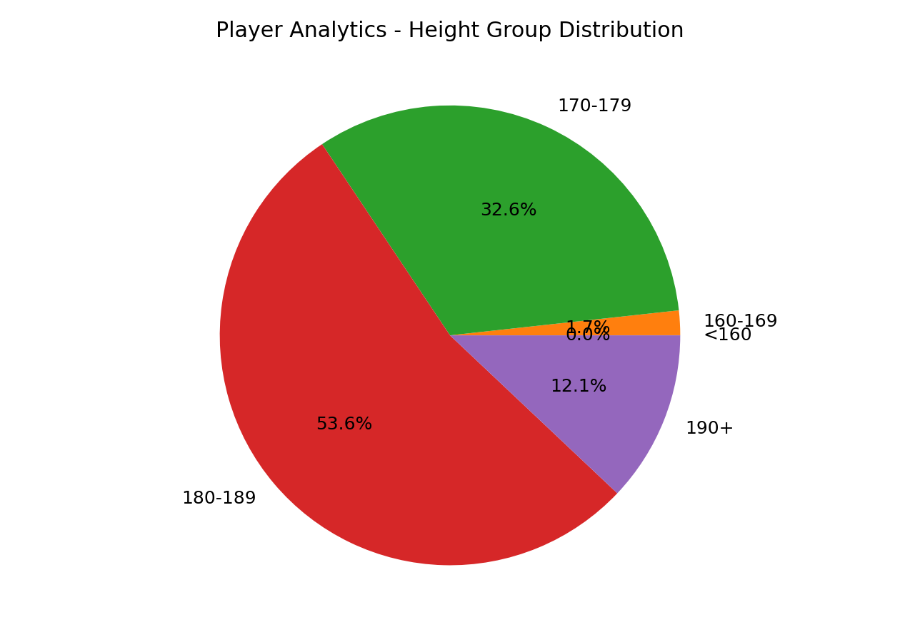
Output: Height Group Distribution
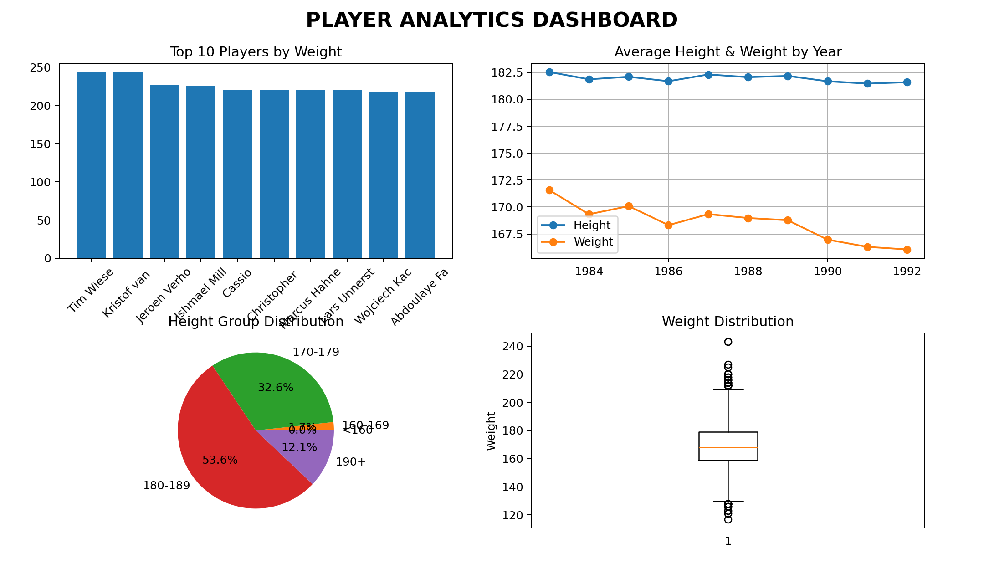
Output: Player Analytics Dashboard
- Player Analytics Dashboard visuals created in Power BI using the Player dataset.

Result:

EXPT NO:6C | DATA VISUALIZATION USING POWER BI (HOTEL BOOKING)

Aim:
To clean, preprocess, and transform the raw Player dataset, load the clean data model into Power BI, and build an interactive visual dashboard to analyze player details, height and weight patterns, player demographics, and related metrics.

Algorithm:
- Import Dataset: Load Player.csv into the working environment and Power BI.
- Remove Duplicates: Identify duplicate rows across all fields and remove them.
- Handle Missing Values: Check and appropriately handle missing values in player_name, birthday, height, and weight.
- Clean Data: Remove unnecessary columns and correct invalid numeric or date values.
- Transform Data: Convert birthday to Date/Time and extract the birth year, month, and day.
- Convert Numeric Data: Format height and weight as appropriate numeric data types.
- Create Measures: Create measures for Total Players, Average Height, and Average Weight using DAX.
- Create Visualizations: Create bar, line, and pie/donut charts to analyze player data.
- Add Filters: Add slicers for Year, Height Group, and Weight Group for interactive filtering.
- Build Dashboard: Arrange all cards, charts, and slicers into a meaningful Player Analytics Dashboard.
Output:
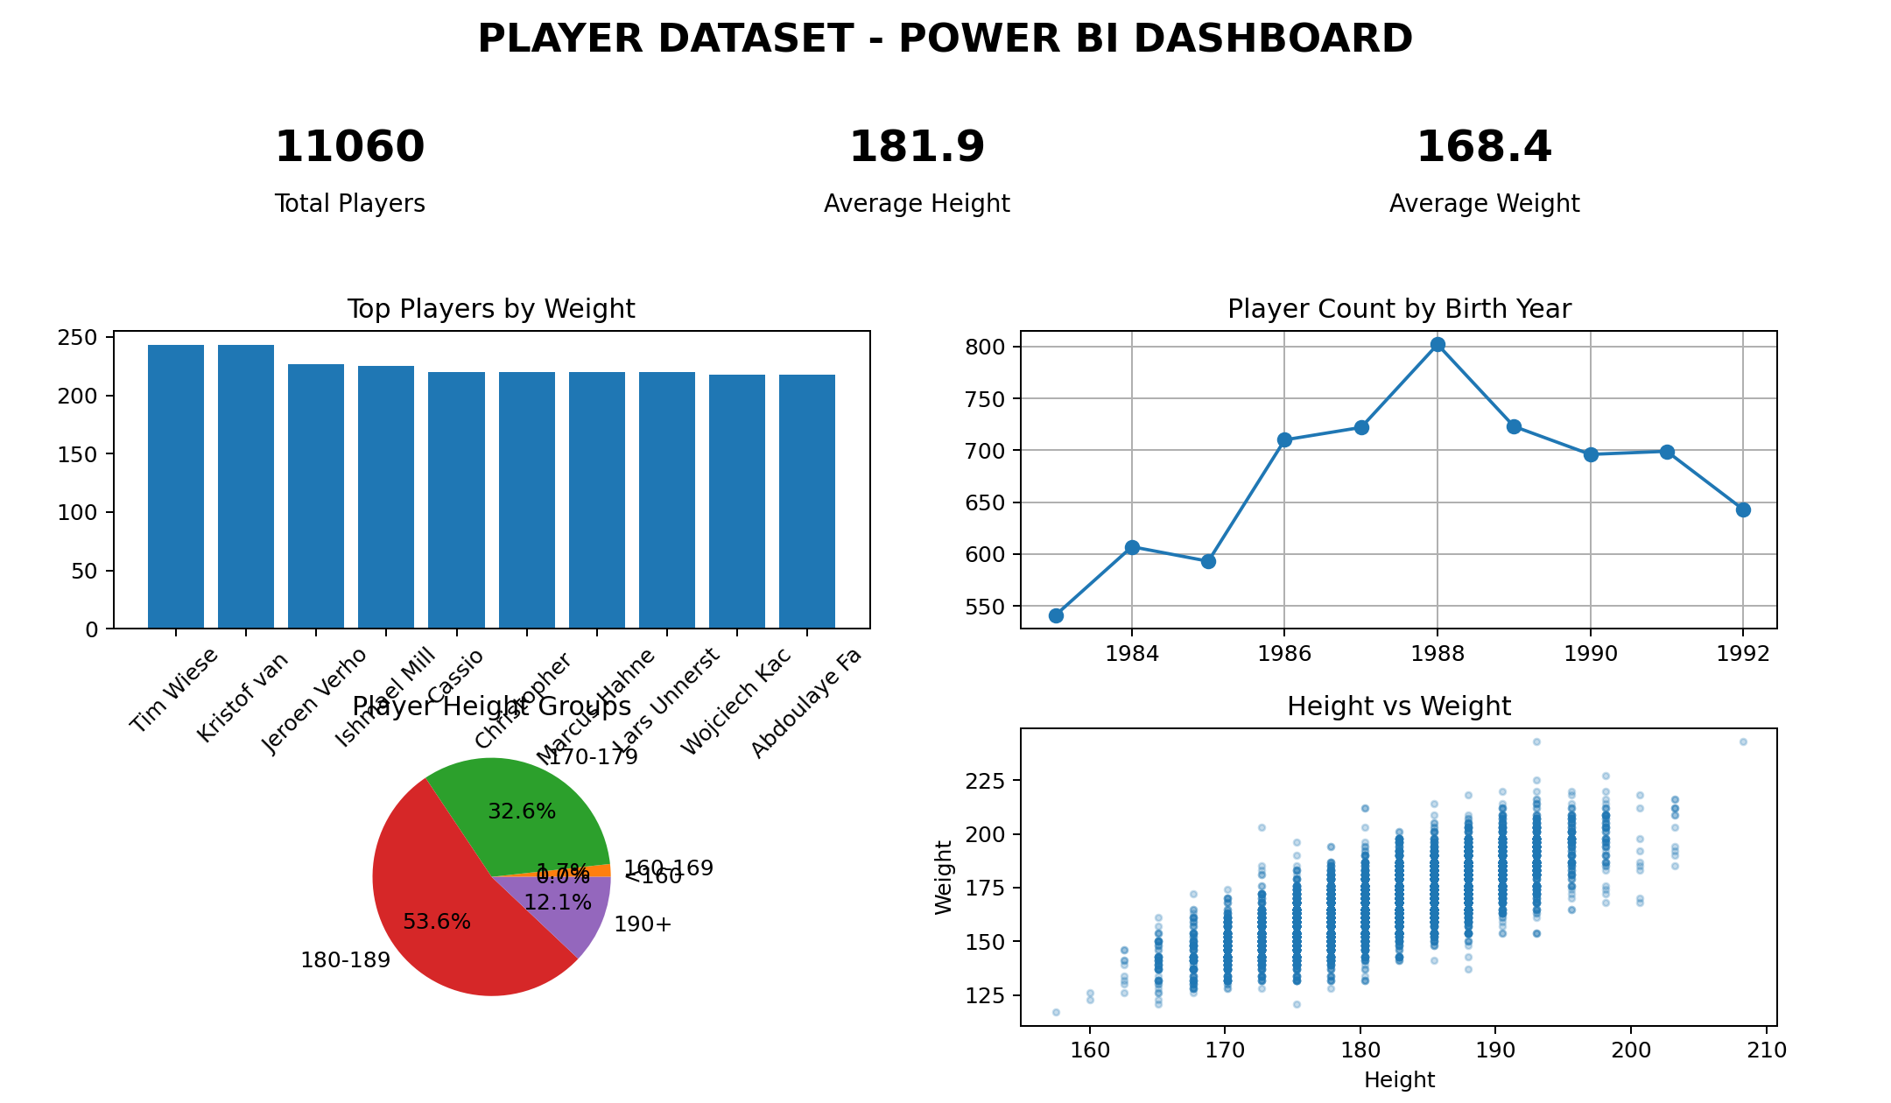
Output: Player Analytics Dashboard

- Player Analytics Dashboard output created in Power BI using the Player dataset.

Result:

